|  |  |  |
| --- | --- | --- |
| Thursday April 11th - Arrivals begin 11:00 CST for light lunch + Meet & Greets | | |
| 12:00 – 12:45 CST Kickoff: Welcome, Introductions, and Anti-trust Meet the CCRO members and our guests as we go around the table. Paul will get us started again with the anti-trust statement…  I’m excited to introduce some new members and welcome guests to the meeting! |  | Bob Anderson  Executive Director  at CCRO  *CCRO Board Member* |
|  | Paul Turner  Partner at Womble Bond Dickinson  *CCRO Board Member* |

|  |  |  |
| --- | --- | --- |
| CCRO “Cyber Minute” Mario will help us kick off with a thought provoking insight into something that a CRO may want to do regarding managing their personal cyber risks… |  | Mario Chiok  Executive Director  at CCRO  *CCRO Board Member* |

Day 1 Member Roundtable Begins:

Day 1 Zoom Link: <https://us02web.zoom.us/j/2813822538?omn=88157033441>

|  |  |  |
| --- | --- | --- |
| Topic | Discussion Hosts | |
| 12:45 to 2:15 CST Energy TransitionClick for full slide  Working GroupUpdates and new plans for this year Our CCRO community of energy companies recognizes that to transition from hydrocarbon reliance, many new risks and opportunities must be understood & managed. For example, renewable asset deployments require significant capital investments and operational changes, may result in stranded costs, and are often developing more rapidly than related markets, corporate strategies, or hedge instruments.  This group aims to address these diverse challenges so as to bring understanding and establish best practices that lead to advancement of our industry’s risk management.  This session will include:   1. Working Group Review of 2023 2. Regulatory Update    1. SEC Rule highlights (JP)    2. EEMAC Update (BA, MP) 3. New Markets    1. Hydrogen Update 4. Survey Discussion    1. Working Group survey strategy (in-person, virtual)    2. S&P survey review    3. Commence in-person survey 5. 2024 Plan Forward    1. Survey results and observations    2. Upcoming webinars    3. Join the Group   …Be sure to check out these webinar video links available here:   1. [Landing page for the group, with links to webinar videos to date…](https://www.ccro.org/energy-transition-webinars) |  | Jamila Piracci,  Principal  at **Roos Innovations** |
|  | Nithya Venkatesan,  First VP – Risk **Navitas Assurance Ptnrs** CCRO Board Member |
|  | Paul Turner,  Partner at **Womble Bond**  Topic Leadership CCRO Board Member |
|  | Victor Yu,  Executive VP  **KWA Analytics** |
|  | Mike Prokop,  Managing Director  at Alliance Risk  Co-Project Manager  [Remote] |
|  | Tom Birmingham,  Former VP Compliance  at Emera  Co-Project Manager  **[Remote]** |

|  |  |  |
| --- | --- | --- |
| Topic | Discussion Hosts | |
| 2:15 to 2:45 Battery Storage Assets and Risk ManagementPropose Next Steps? We’ve had several rounds of discussions about the technical issues with battery storage assets & trading around them.  We’ll continue our ongoing discussion of ideas on where our initiative should focus for a valuable deliverable that members will benefit from:  How can batteries be used as risk mitigation measures, specifically in portfolios heavy in intermittent renewables?  How does one go about valuing a battery storage asset? What are the key drivers of value and the risks inherent in such a valuation?  Are batteries just a passing craze or will they provide significant benefits to the grid in 15-20 years?  What are the financial alternatives to batteries that can convey similar benefits without the obligation to schedule a physical asset?  Other areas to focus? Interested? Pre-Meeting Online Resources to Look Into: [Web page with background & videos from recent discussions](https://www.ccro.org/battery-storage-risk-management) |  | Bob Anderson  Executive Director  at CCRO |
|  | Mike Kirschner  US Managing Director  Habitat Energy |
|  | Nick Dazzo  Managing Director, Trading at **Spearmint Energy** |

15 Minute Break

|  |  |  |
| --- | --- | --- |
| Topic | Discussion Hosts | |
| 3:00 to 3:45 Advancing “Risk” Back Office Best PracticesOur survey results bring direction to our discussion Most members believe that the Back Office for commodity trading is a very essential control tool which is complex and unique, requiring an understanding of the commodity trading business.  Therefore, in their opinion, the Back Office, as a part of our CCRO recommended "Front/Mid/Back" office model, should be subject to performance benchmarking among trading organizations, rather than financial accounting in general.  So, we hosted a poll of members to address the fundamental question of: A) Should we think about Back Office as a generic accounting function? ...or … B) Should it be a specialized group with commodity business knowledge, understanding commodity invoices, CTRM knowledge, ability of creating shadow invoices, and disputing them with counterparties?  *This discussion will review* the poll results and start the conversation into some ideas about what the CCRO members can do together to advance best practices in this critical area of a commodity trading business…  [Draft Survey Results & Analysis](https://library.ccro.org/CCRO_Back_Office_April2024/) |  | Alex Zhukovski  Chief Risk Officer  At National Grid |
|  | Sid Jacobson  Vice President - Risk Mgt  At CLECO Corp. Holdings |
|  | Raquel Loaiza  Head of Trading Operations  At Total Energies |
|  | Eugen Luja  Chief Risk Officer  At Repsol |

|  |  |  |
| --- | --- | --- |
| Topic | In-person Discussion Hosts | |
| 3:45 to 4:15 Industry Credit Risk Best PracticesDraft chapters This project seeks to publish a comprehensive white paper, currently planned to include ten chapters. Chapter ten is complete, with other chapters currently in a draft form.  We will go over the sections, discussing our proposed approach to engage many credit managers at member companies to contribute to the editing process.  The chapters are available for live editing now on the CCRO’s SharePoint server. We want to urge each CCRO member to have their credit risk manager get involved in this group as we finalize the draft chapters… Interested? Pre-Meeting Online Resources to Look at: [Collection of Chapters available for editing & commenting](https://ccro908.sharepoint.com/:f:/r/sites/CCRODraftDocuments/Shared%20Documents/CCRO%20Draft%20Documents/Credit%20Risk%20Best%20Practices?csf=1&web=1&e=RlmddT) (via your CCRO Sharepoint) |  | Nithya Venkatesan  First VP – Risk  Navitas Assurance Partners  CCRO Board Member |
|  | Miguel Correa  Head of Credit  at ARAMCO Trading |
|  | Eric Twombly  Director of Credit Risk  at Golden Pass LNG |
|  | Amir Andani  CRO  At Just Energy |

|  |  |  |
| --- | --- | --- |
| Topics | In-person Discussion Hosts | |
| 4:15 to 4:45 Solving Risk Staffing ChallengesProposal: A New “Risk Staffing Advisory Board” As we have been discussing, finding qualified risk staff is a major challenge. For some, this is one of the most critical operational risks being faced today.  We want to explore ways to strengthen our recruiting positions when searching for experienced, but early career staff. We want to explore some new ideas for a CCRO Advisory board in this area. Additional Online Resources to Look at: [Initiative web page with videos & survey results…](https://www.ccro.org/risk-staffing-solutions) |  | **Nigeria Bloczynski**  Managing Director at **Prism Risk** |
|  | Morgan Davies  Director Strategic Risk  at **The Energy Authority**  *CCRO Board Member* |
|  | Bob Anderson  Executive Director  at CCRO  CCRO Board Member |

5:30 ~ Meeting Day 1 wrap-up

Walk to reception at

|  |  |
| --- | --- |
| 5:30 to 8:00 CCRO Reception and Dinner Join us to catch up with friends and explore the issues that we are discussing in the CCRO  Just a two block walk from the meeting: [GOOGLE MAP…](https://maps.app.goo.gl/LDdfnykt5ZPjSGTN9)  1605 Post Oak Blvd, Houston, TX 77056 |  |

|  |  |  |
| --- | --- | --- |
| Friday April 12th - Arrivals begin 8:30 CST for coffee + Meet & Greets | | |
| 9:15 – 9:30 CST Kickoff: Welcome, Introductions, and Anti-trust I’ll introduce any members that missed day 1.. Paul will get us started again with the anti-trust statement… |  | Bob Anderson  Executive Director  at CCRO  *CCRO Board Member* |
|  | Paul Turner  Partner at Womble Bond Dickinson  *CCRO Board Member* |

**Day 2 Zoom Link:** [**https://us02web.zoom.us/j/2813822538?omn=86982849809**](https://us02web.zoom.us/j/2813822538?omn=86982849809)

|  |  |  |
| --- | --- | --- |
| Topic | Discussion Hosts | |
| 9:30 to 10:15 CST Risk Management in Global LNGA Short-Term Project for this initiative is Underway This CCRO initiative’s goals are to support development of more favorable industry conditions & resources that support the advancement of LNG risk practices.  We hope to help create conditions where the fast growing LNG trade industry may develop and prosper while avoiding the risk management failures that other industries have seen in the past.  Our European and US members are working to get under way with a short term project. in the short term, we’d like to address a lack of clarity that current regulatory reporting policies have created. In the longer term, we have numerous challenges to consider tackling..  Please join this discussion. As the team gets underway to address the short term, we need to get the feedback from all members on our best approach and any topics we might prioritize… Additional Online Resources to Look at: [Link to more info at CCRO website…](https://www.ccro.org/lng-trading-risk-management)  [Slide deck for the meeting…](https://library.ccro.org/Meeting-4-2024-LNG/) |  | Eugen Luja [Remote]  VP Head of Risk  at Repsol  Group Co-chair |
|  | Joe Raia  Chief Commercial Officer  at Abaxx Exchange |
|  | Brian O’Neal  Member Emeritus  Former Partner at KPMG |

|  |  |  |
| --- | --- | --- |
| Topic | Discussion Hosts | |
| 10:15 to 11:00 Scenario Analysis Practices for Risk ManagementA Resurgence in Interest Given the Scope of Industry Change In recent CCRO meetings, we have discussed the enormous market, technological and regulatory uncertainties facing the industry sectors in which our membership operates. These uncertainties have far reaching implications for risk management and the strategic decisions our organizations face.  Scenario analysis is an essential tool designed to explicitly incorporate uncertainty into strategic decision making and risk management. Possessing insightful scenarios is essential to broadening thinking about the range of potential future outcomes and identifying potential strategic alternatives. Scenarios are particularly important in multi-stakeholder situations in that they enable stakeholders to have a shared understanding and a shared vocabulary for discussing the future.  We’d like to advance our thinking with respect to how to best implement this method to be effective for the risk officer. For example:   1. Developing effective scenarios and creating management buy-in 2. CCRO standard nomenclature    * Develop consensus and publish terminology to avoid confusion    * Encourage shared scenario examples 3. Having impact on decision making    * Examples of ways to ensure the analsyes' impact    * "In-crisis" workflow examples  Interested? Pre-Meeting Online Resources to Look Into: [Initiative web page with background and videos](https://www.ccro.org/scenario-risk-management-best-practices) |  | Chris Dan  Partner  At Publicis Sapient |
|  | Brian O’Neal  Member Emeritus  Former Partner at KPMG |
|  | Eric Twombly  Director of Credit  At Golden Pass LNG |

|  |  |  |
| --- | --- | --- |
| Topics | Discussion Hosts | |
| 11:00 to 11:30 CST Risk Technology Users RoundtableEmerging Challenges & Opportunities We want to ask members to weigh-in on the interest levels for various proposals that are being considered as we kick-off this unique on-going initiative. In addition an event advisory panel would be very helpful for ensuring our coverage of each topic is comprehensive… |  | Morgan Davies  Director Strategic Risk  at The Energy Authority  *CCRO Board Member* |
|  | Victor Yu,  Executive VP  at KWA Analytics |
|  | Bill Lawrence  Chief Delivery Officer  at Itegriti |

|  |  |  |
| --- | --- | --- |
| Topics | Discussion Hosts | |
| 11:30 to 12:00 CST Power Market Developments & RiskEmerging Challenges & Opportunities Since our initial work to publish a paper providing guidance for ISOs concerning the best practice principles for effective risk management, there is a new team of members coming together to explore recent developments and associated challenges.  Some of the topics that we want to invite members to share their insights include:  Emerging ISO news relevant to risk professionals  Discussions delving into areas where the CCRO might provide clarification regarding best practices |  | **Nigeria Bloczynski**  Managing Director at Prism Risk |
|  | Morgan Davies  Director Strategic Risk  at The Energy Authority  *CCRO Board Member* |
|  | Bob Anderson  Executive Director  at CCRO  *CCRO Board Member* |

12:00 to 12:45 CST – A Series of Topics for Brief Calls to Action

|  |
| --- |
| CCRO KRI BenchmarkingBenchmarking Initiative Update & ExpansionLet’s update our Trade Operations KRI data We have the data submission templates and on-line viewer for the anonymous benchmarks for late & edited trades. With new updated data, there are sure to be new insights gained! Let’s consider the payment performance KRI proposal Then, we would like to propose a proposed benchmarking initiative which is associated with portfolio credit risk management. We’ll open the proposal to discussion, seeking ideas and participants to develop a plan for proof of concept with actual data.  [Video of first discussion exploring the Payment Performance KRI proposal…](https://library.ccro.org/credit-ori-benchmarking/) |
|

|  |
| --- |
| Model Risk Management White Paper DraftDraft Paper Expanded & Open for Additions/Editing This techinical paper has gone through a few major expansions & edit cycles, such that a very comprehensive draft is available. Let’s work together to publish this insightful and timely paper.  [Video of update presentation from March 2023 meeting](https://library.ccro.org/CCRO-model-risk-concepts/)  [Latest draft paper (As of July 19, 2023)](https://library.ccro.org/1vsg8pe/) |

|  |  |  |
| --- | --- | --- |
| Cyber Risk and the CRODiscussion of Proposed Work Products We want to develop a series of webinars to provide insights into this field that is quickly crossing into the purview of the CRO. Let’s explore our thoughts on how this could/should develop… |  | Bill Lawrence  Chief Delivery Officer  at Itegriti |

|  |
| --- |
| Trading Compliance CommitteeFocus Topics? We want to ask members to share thoughts on where we would like to have this standing committee focus its future discussions. What are the issues with internal or external compliance that we see as most challenging today? |

|  |  |  |
| --- | --- | --- |
| Open Discussion re Other Topics to Consider? We want to allow some time to for members to raise issue that we may not yet be focused on.… |  | Bob Anderson  Executive Director  at CCRO  *CCRO Board Member* |

12:45 MEETING CLOSES

CCRO RSVP List

As of Weds Apr 10…

If you are not on this list, but intend to come, please do register by completing this quick on-line form:

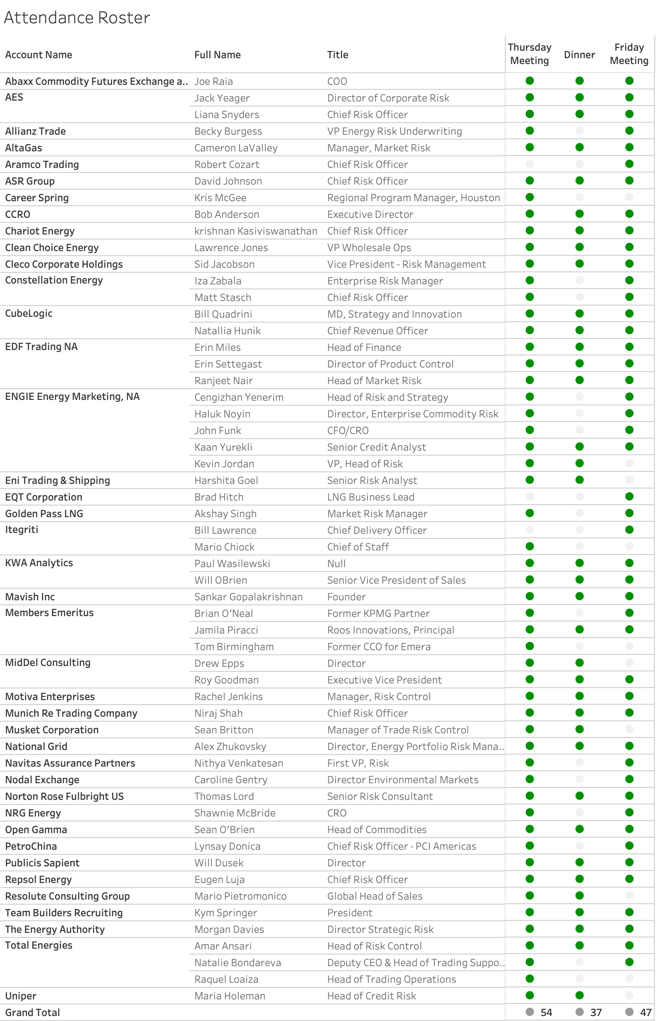Thank you!

[REGISTER HERE](https://brzqirlglg4.typeform.com/to/IciKB2xG)